Reversing CTF
By: Tehila Chananayev - 325435956

Introduction
The purpose of the assignment is to simulate a real-world cybersecurity challenge, where we must analyze a fancy binary file, understand its logic, and overcome three consecutive steps using techniques learned during the course.
The scenario presented is that we are in the role of special operations specialists, tasked with protecting Israeli pilots by disabling an enemy anti-aircraft system. As part of the mission, we are warned about decoys and must identify the correct target through careful analysis.
This description includes a full explanation of each step, the tools I used, the reverse engineering process, and how I gradually arrived at the correct solution. I have documented each step to emphasize understanding over guesswork, and where possible, I have supported my reasoning with screenshots or code snippets.

I did not use any of the help files on the course website.

Sage1
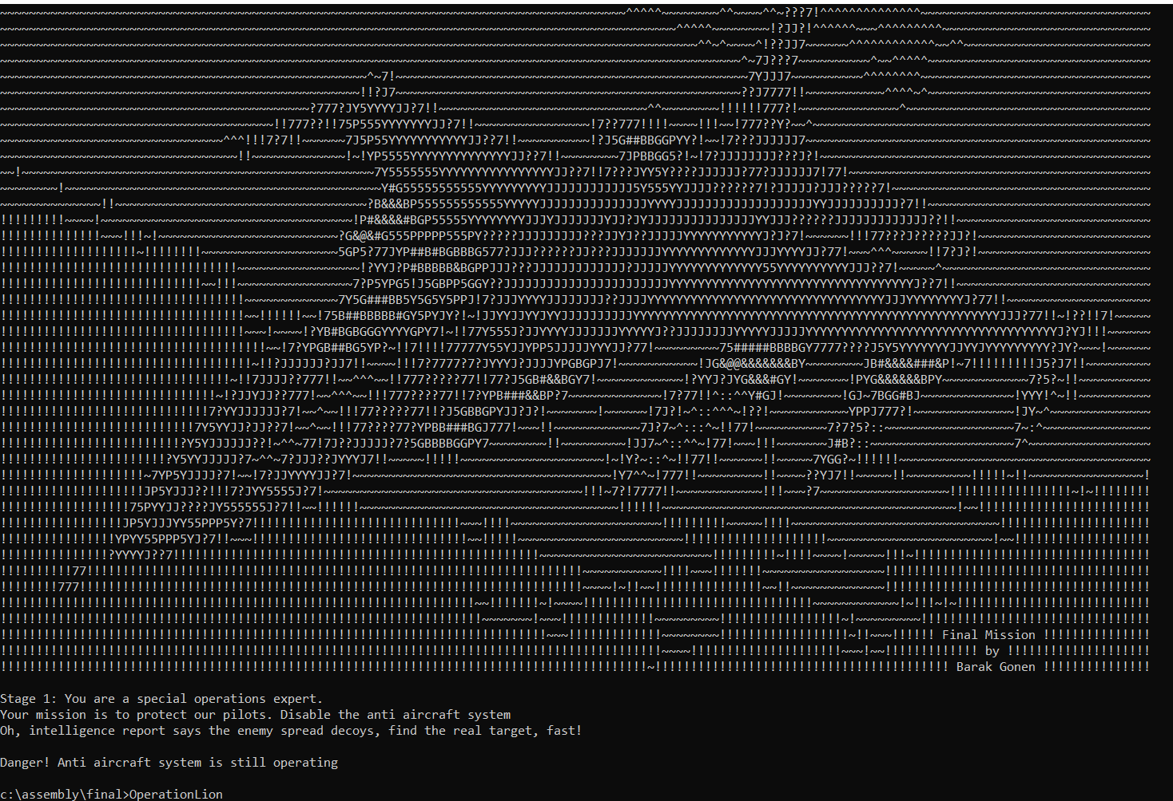
First of all I ran the program and saw the following output:

Drawing a plane from scratch and printing the following caption
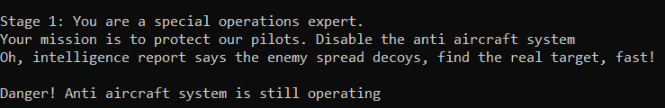
The scenario presented is that we are in the role of special operations specialists, tasked with protecting Israeli pilots by disabling an enemy anti-aircraft system. As part of the mission, we are warned about decoys and must identify the correct target through careful analysis.
Stage 1: Initial Analysis and Approach
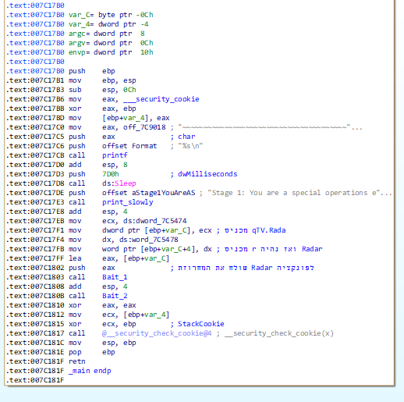
Once I fully understood the task, I began the reverse engineering process. My first step was to open the binary file in IDA, where I began examining the code. At first, I noticed that the program printed a string representing a drawing of an airplane, and then printed another string. This sequence of actions was my first clue that there might be important information hidden in the output. As I continued to analyze the disassembled code, I identified two key functions that seemed to be integral to the logic of the program that took the string Radar as input. And I thought that these functions would actually lead me to the solution.

So I went into each of the functions and tried to understand what they do.
First function:
I hit F5 to get to the C language display What the function actually does is this: The Bait_1 function is executed on a string (Radar), and performs an XOR operation twice on each character in the string with the same value (0x2A). The function does not change the string to much. In fact, it performs an XOR twice on each character, which returns the character to its original value, and does not change anything in the string.

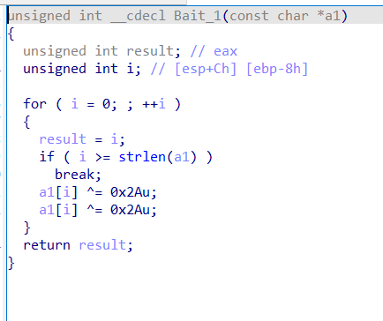

Step 1: Investigation and Hypothesis
After analyzing the initial behavior of the program and the first function, I hypothesized that the purpose of the XOR operation in the Bait_1 function might not be as simple as it seemed. While the function performs an XOR operation twice on each character in the input string, which essentially returns the characters to their original state, I wanted to verify whether this was indeed the case.
To test this, I examined the result of performing the XOR operation on a sample string and found that after a single XOR operation, the result was "Radar=xNKKX". However, this output did not reveal any useful or meaningful information, and I realized that it did not help me move forward with the solution. This led me to conclude that the function might not be the key to deciphering the target information.
I also considered another potential approach: the string representing the airplane drawing printed earlier in the code. This looked suspicious, and I thought that it might contain hidden data that could be important. I suspected that perhaps performing an XOR operation on this string would yield some useful information, so I prepared to write a small program that would process this string and perform an XOR on it. However, before I continued with that program, I decided to examine the second function in the code. I was hoping it would provide some more insight or direction on how to proceed.
This turned out to be a seductive function to waste my time.
Step 2: Memory Search and Debugging
After reviewing the program output further, I noticed the string: "Danger! Anti-aircraft system still running". So I thought I would search for the string and see what was causing this error, i.e. what test failed, but I couldn't find it anywhere in the code itself. I suspected that it might be hidden deeper within the program, perhaps in memory.
To investigate further, I decided to search the program's memory. I used the Alt + B shortcut to open the Memory Search window and entered the string "Danger! Anti-aircraft system still running".
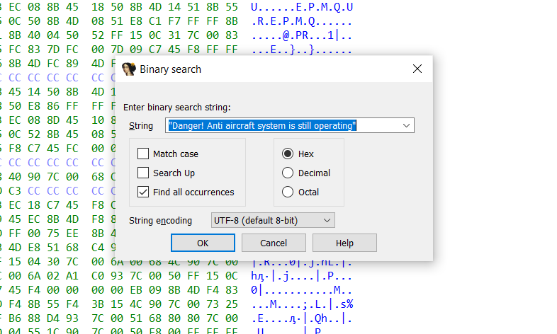

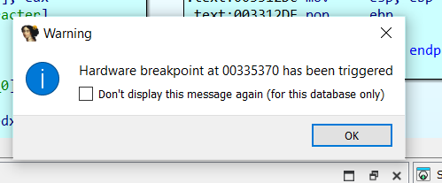
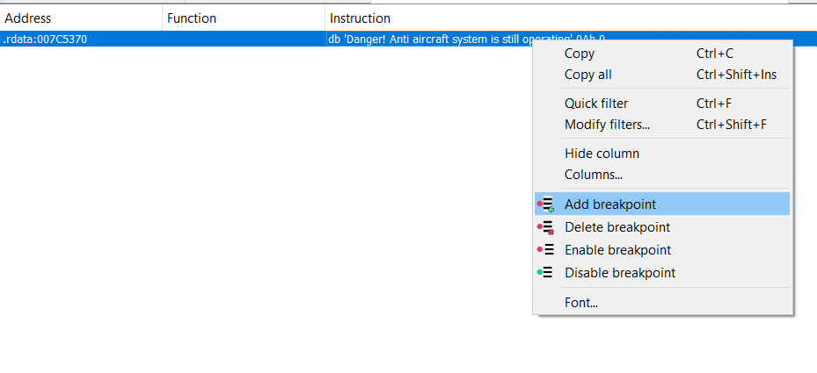
After the search, I set a hardware breakpoint on the string, which allowed me to pause the program when it tried to access this specific memory area.

I then ran the program until the hardware breakpoint was triggered. This allowed me to examine the state of the program at the exact moment it was about to display the message. By following the steps using Ctrl + F7, I was able to follow the flow of the program and understand what led to the message being printed.
After identifying the code segment responsible for printing the message, I began to investigate the program in depth to determine what actions were required to disable the anti-aircraft system.

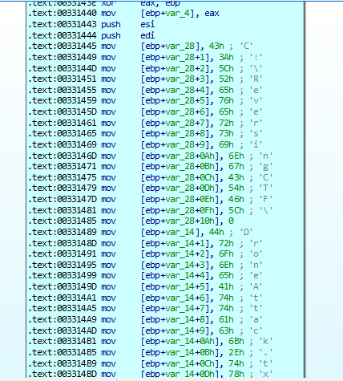
I saw that there was a string that looked like a path.

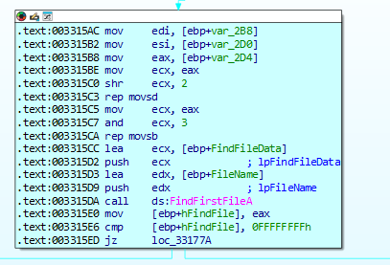
The path string C:\ReversingCTF\DroneAttack.txt has been constructed and is used within the code. The program uses this file path to check if the file exists. It first creates the path string by concatenating "C:\ReversingCTF\" with "DroneAttack.txt". The individual characters of this path are copied byte by byte from memory into the FileName variable.

This code snippet checks if a file exists in the path given to it (C:\ReversingCTF\DroneAttack.txt). It does this by using the FindFirstFileA function of the WinAPI, which performs a file search File Management. If the function is able to find the file, it returns information about the file, and if not, the program stops searching.
If the file does not exist (if FindFirstFileA returns an invalid value), then the program prints the message:

"Danger! Anti aircraft system is still operating\n"

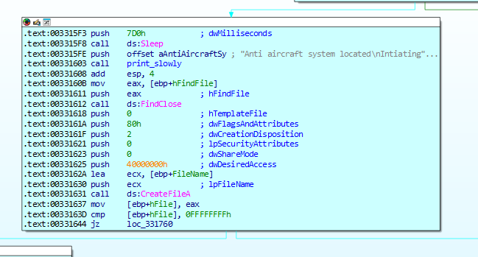

In this part, the Create FileA function, also from winAPI, verifies that the file was indeed opened successfully.
At this point, I understood that in order to disable the system and progress to the next stage, I needed to create the required file in the specified location. The program checks for the existence of the file C:\ReversingCTF\DroneAttack.txt. If the file is found, the system will proceed to disable the anti-aircraft system and print the message:
Great job. Anti aircraft system is disabled
To proceed, I manually created the file DroneAttack.txt in the folder C:\ReversingCTF\, and upon running the program again, the system was successfully disabled, allowing me to move on to Stage 2.
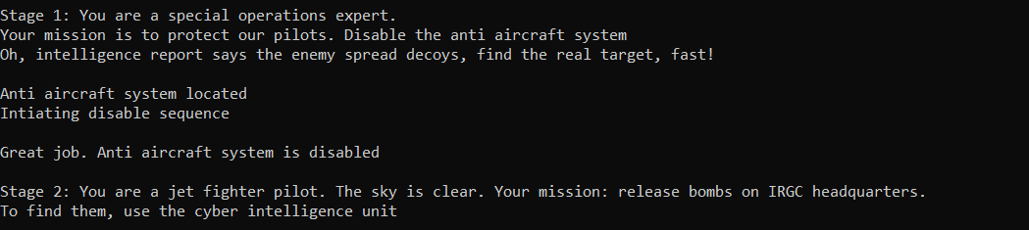

Sage2
This is the next task.
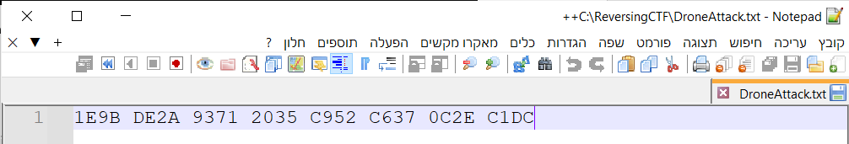
After step 1 in the file I created the following content is recorded

And a DLL file was also created in the ReversingCTF folder called AttackIRGC.dll
first of all, I knew I needed to check and load the DLL file to make it do something.
Investigation and Hypothesiss:
I put it in CFF Explorer and also in H&D to first investigate what I was seeing and saw that it was not in PE (Portable Executable) format, which is the standard format for executable files in Windows. The MZ header, which usually marks the beginning of an EXE or DLL file, was missing. This led me to the conclusion that it needed to be fixed manually or with the help of additional tools.
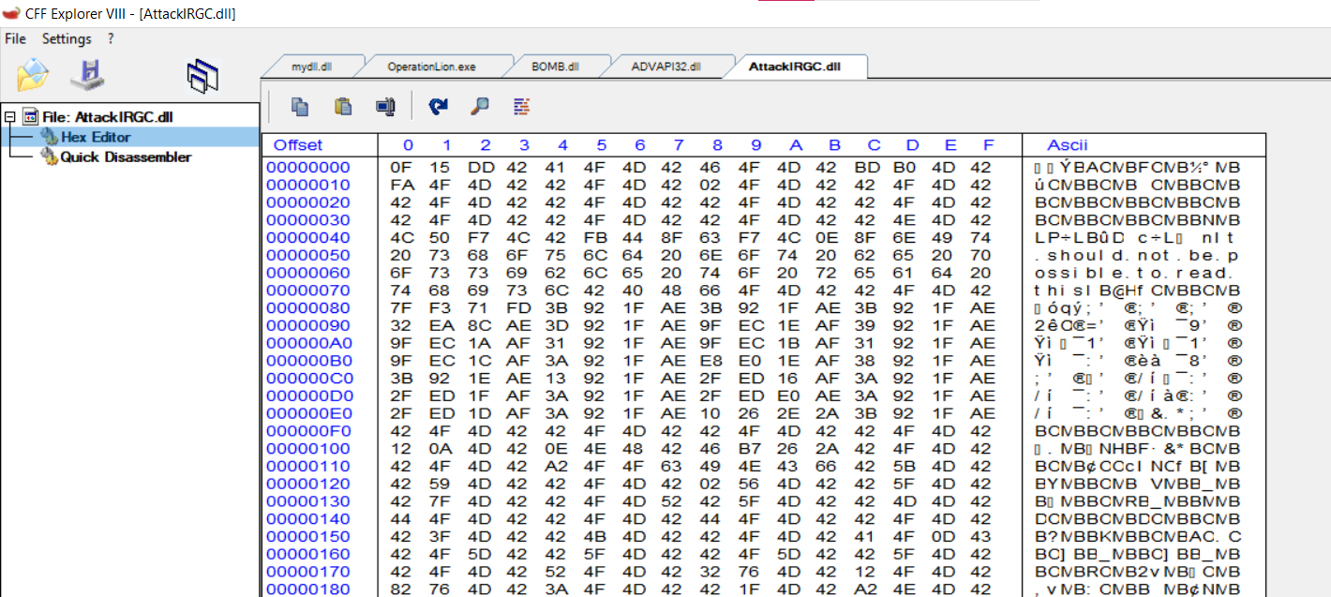

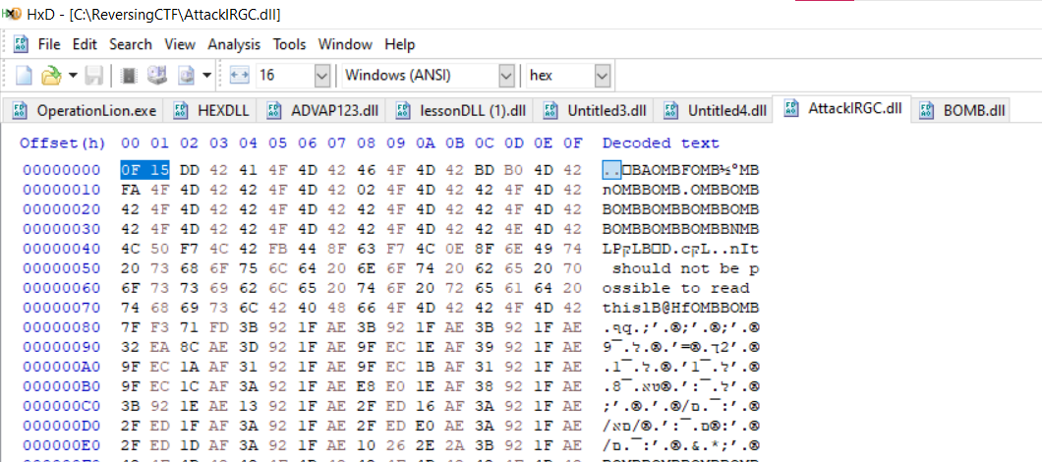

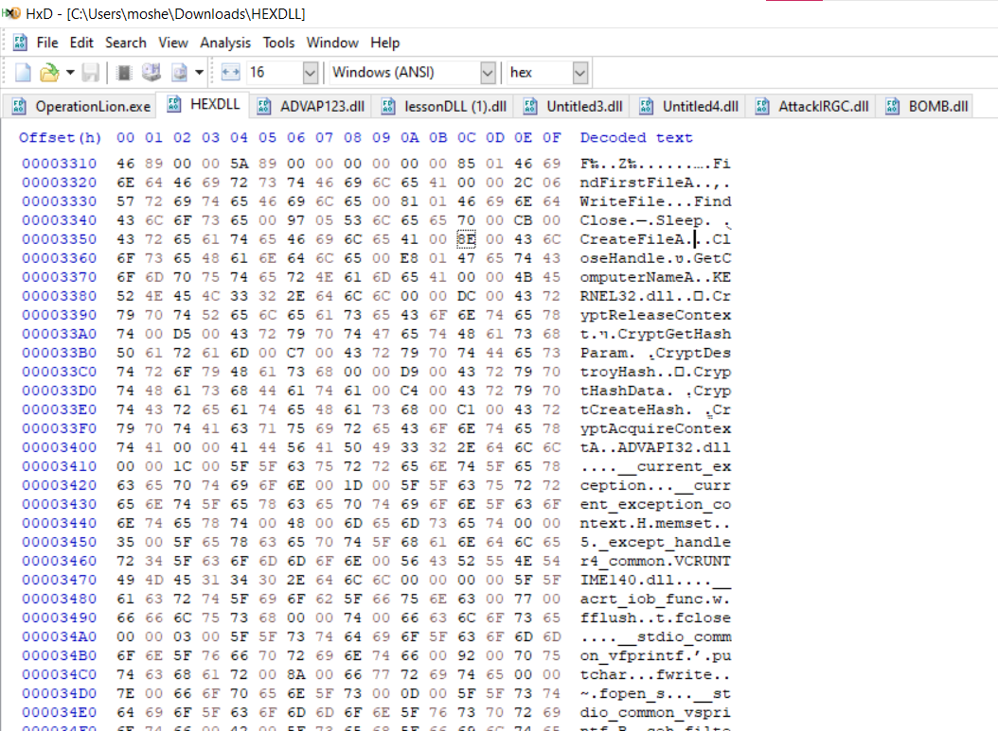
I thought about making changes to the DLL file using H&D and manually changing it to get the PE format. I added the MZ header at the beginning along with the full header, but that didn't work either. I searched the file and saw that there were no .TEXT or .DATA sections, so I realized that this was no longer the solution. I thought maybe I could take the data that goes into the DLL in HEX format from the program and play with it. I even considered creating a wrapper for the existing DLL using C code, but I just got stuck.

So when I saw that this was not the case and I was getting into trouble, I looked again at the task of stage 2 "To find them, use the cyber intelligence unit" - I realized that I needed to use cyber, meaning something encrypted that needed to be decrypted, etc. Then it occurred to me that maybe the DLL file was encrypted and the key was the characters that were entered in the program for the file I created in stage 1, so what encryption could it be? Encrypting with AES doesn't make sense because you also need an IV. The best thing that worked for me was XOR, which isn't too complex. Then I decided to try it (I asked the chat if there was a site that decrypted it or I would make some code in Python). I inserted the file into an online site that decrypted it for me with the key and the key wasn't correct. I tried a few more strings related to work. I tried ReversingCTF, IRGC and it didn't work.
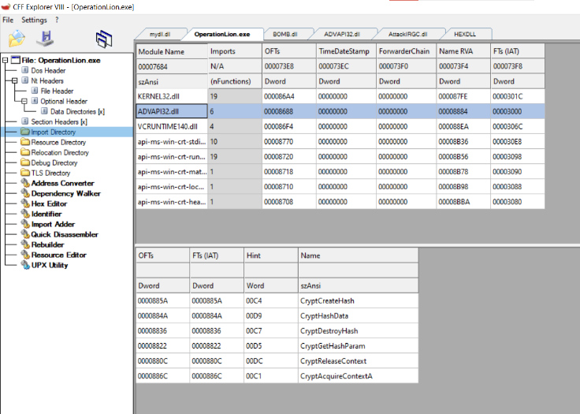

In addition, I looked at the OperationLion.exe program in CFF explorer to see what DLL the program uses and what functions, so I later changed the name of the DLL after decoding to ADVAPI23.dll.
A way to a solution
Then I thought I need, the beginning of the file should be in PE format, so there is the string MZ, which is 4D 5A HEX at the beginning, so I looked at the characters at the beginning of the DLL file, the characters were OF 15, so I thought what would give me MZ
0F XOR X = 4D
15 XOR X = 5A

X = 0F XOR 4D = 42 = 'B'
X = 15 XOR 5A = 4F = 'O'
Therefore, the beginning of the key should start with 'BO'. I thought about what could be that starts with these characters and is related to the mission, and I looked again at the mission "Your mission: Drop bombs on the Revolutionary Guard headquarters" I tried the key that equals "BOMB" and indeed that was the key.

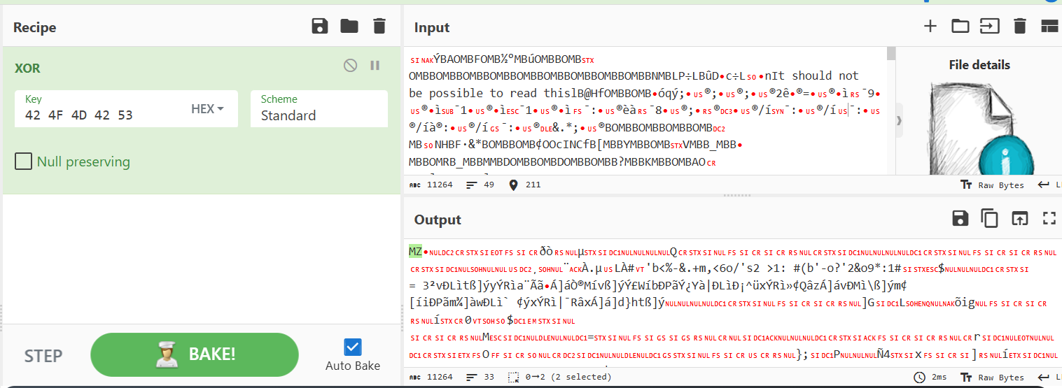
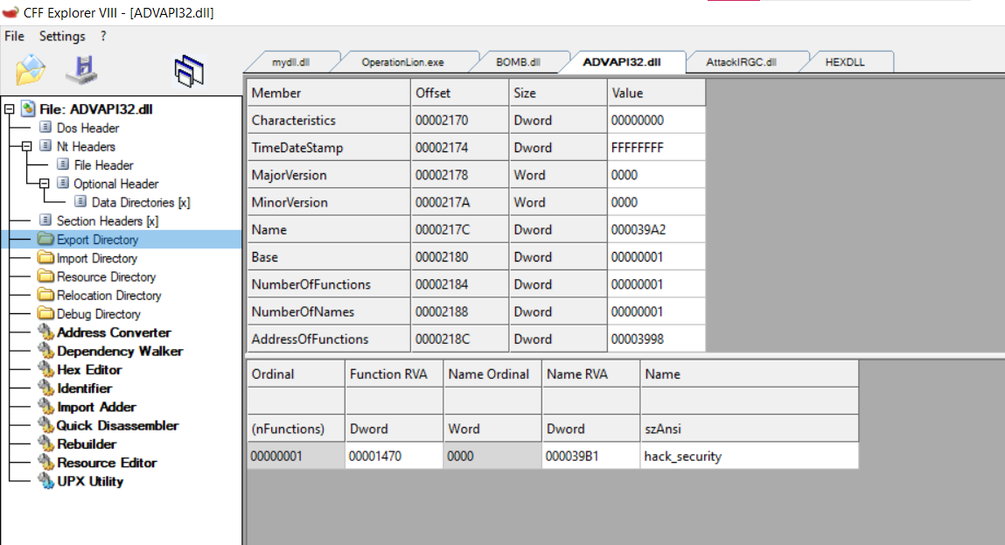
After I broke the encryption, I opened the DLL file in CFF Explorer to see what was in it.
So I wrote some C code in Visual Studio to load the DLL into the program
(I took the Operating Systems Run Time Tutorial in DLL Import 8.3.3)
I just changed the path of the DLL and the function to be hack_securty
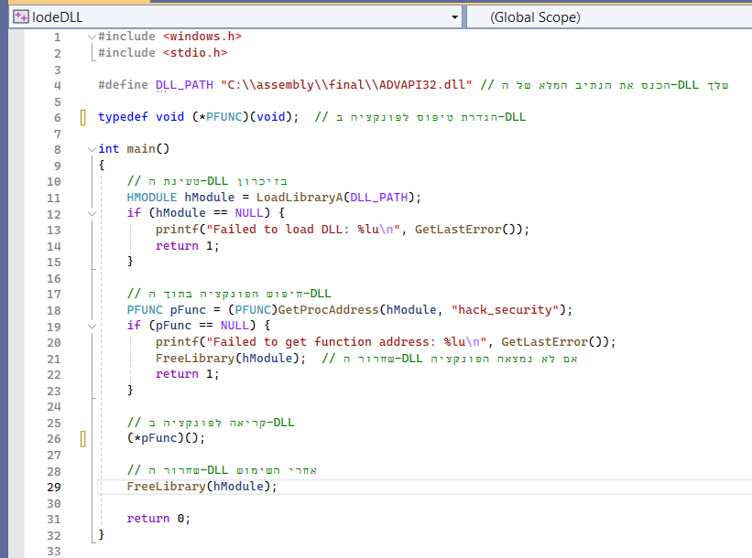
I opened the DLL in IDA.
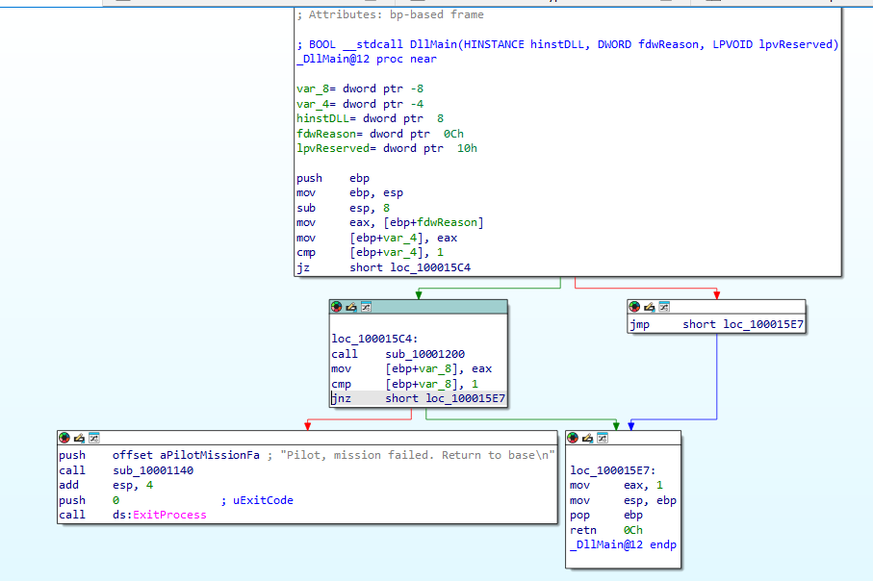

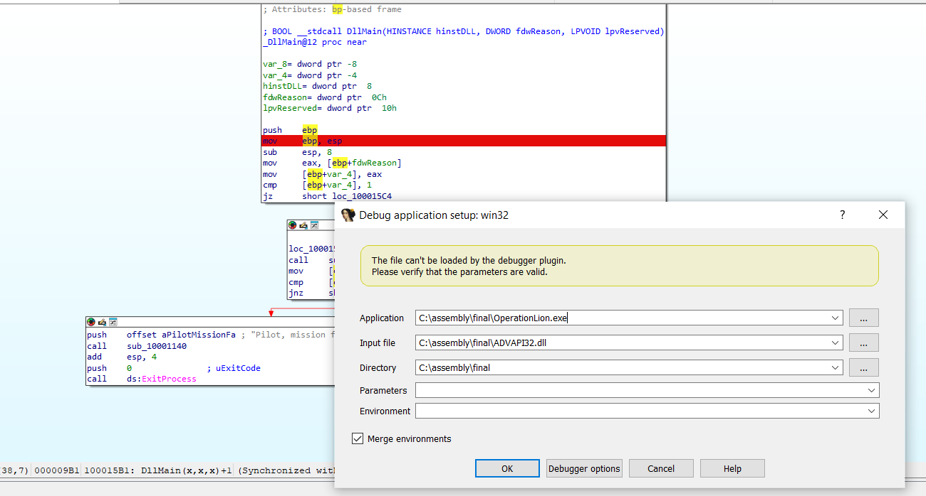

I ran it and it was printed for me -"Pilot, mission failed. Return to base"
I investigated the code in static analysis and saw that there was anti-debugging.
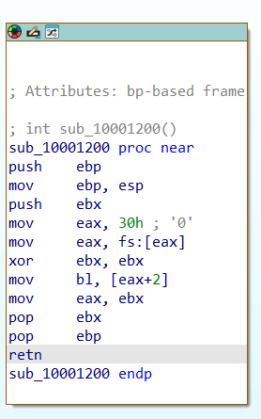
The function checks to see if the process is being debugged by accessing the BeingDebugged field within the PEB (Process Environment Block). If the value in BeingDebugged is 1, this indicates that debugging is enabled, and this is considered anti-debug.

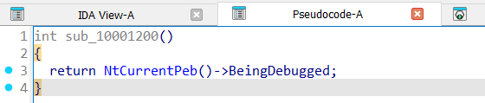

I went into the TLS section of IDA in the Exports tab and saw the code that brings up the success message, and to get to it, the function argument should be 8200.
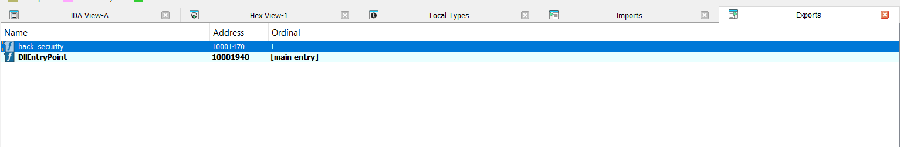
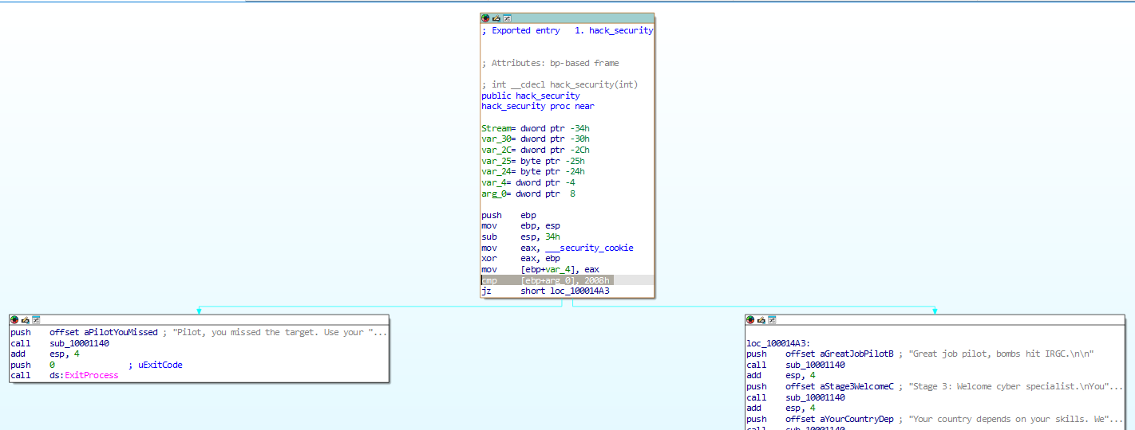

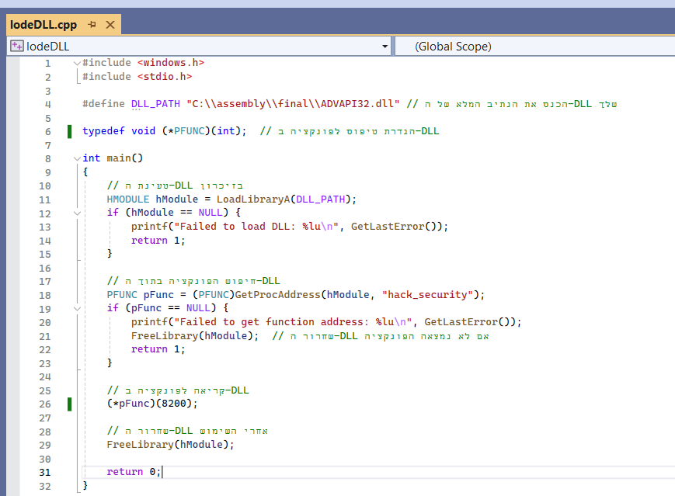
So I changed it to accept an int argument and send it 8200 so that the task would succeed.
I ran it without a debugger then I finally passed a stage and managed to blow up the Revolutionary Guards.
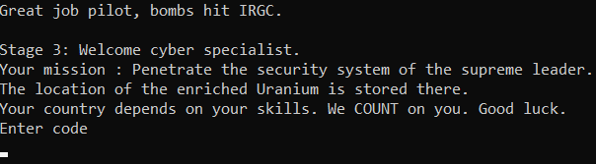

Sage3
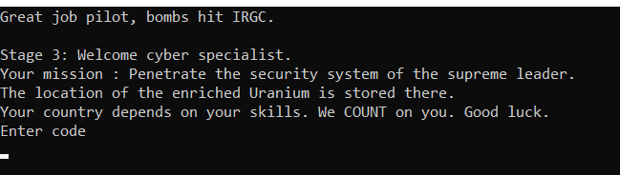
This is the next task.
In this task, I realized that I was supposed to test what code would result in an entry. I entered to investigate the function that checks the correctness of the code using static analysis. The function returns 0 if the test failed and 1 if the test passed.
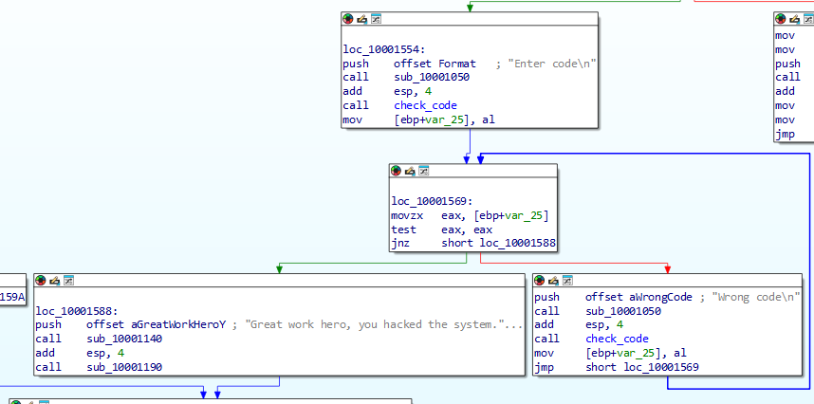
test eax,eax - eax must be equal to 1 to jump to success in printing

First of all, looking at the function on the structure, I see that the function performs a series of tests and loops, and if one of them fails, it returns a result of 0 and stops execution.

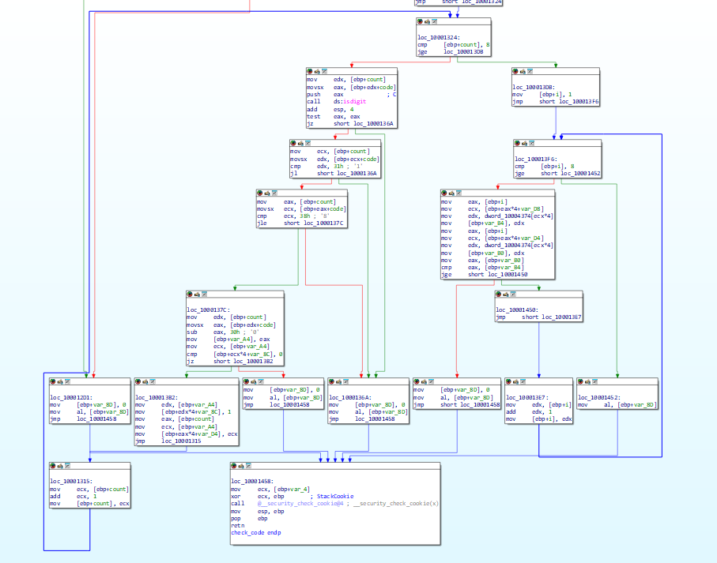
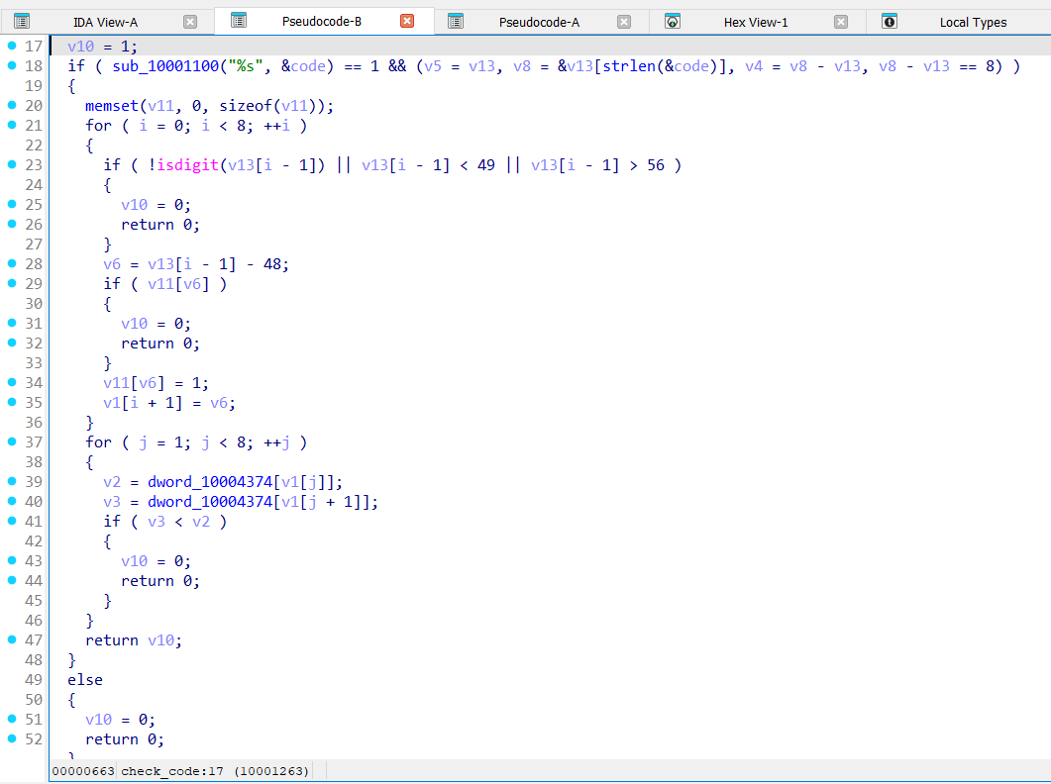
I Press F5 to convert the code, which was more convenient for me to see the entire function.
The function performs the following checks:
1. String length check:
The string must be exactly 8 characters long.
2. Digit check:
Each character in the string must be a digit between 1 and 8 (inclusive).
3. Repetition check:
Each character in the string can only appear once (no duplicates).
4. Ascending order check:
The values in the string must be in ascending order based on the values in the dword_10004374 array. That means each character after the previous one must be equal to or greater than the one before it, according to the values in the array.
If all checks pass, the function returns 1. If any check fails, the function returns 0 and terminates execution immediately.

So first thing is values ​​from 1-8 now the question is in what order
I look at the file that I entered values ​​into in the previous step and convert its values ​​to decimal to know what the ascending order is so that the test will pass successfully.
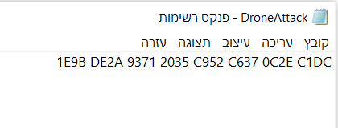

1E9B = 7,835
DE2A = 56,874
37,745= 9371
8,245= 2035
C952 = 51,538
C637 = 50,743
0C2E = 3,118
C1DC = 49,628

0C2E 1E9B 2035 9371 C1DC C637 C952 DE2A
This way the values ​​are arranged in ascending order, so I thought the code that would lead to success would be: 71438652
But it gave an error The code is incorrect
I tried all sorts of codes but it didn't work.
I thought I would arrange the file so that the values ​​were arranged in ascending order and then I would enter the code 12345678 - But it didn't work.
I thought about trying to brute force the code, but there are many possibilities! That's 8! That's 40,320, and it would take time, so I'd better use my brain.
So I thought there was a change in the values ​​in the file and yes I was right there is code that makes changes to the file.
Two loops that iterate over the file value 8 times, the number of values ​​in it.
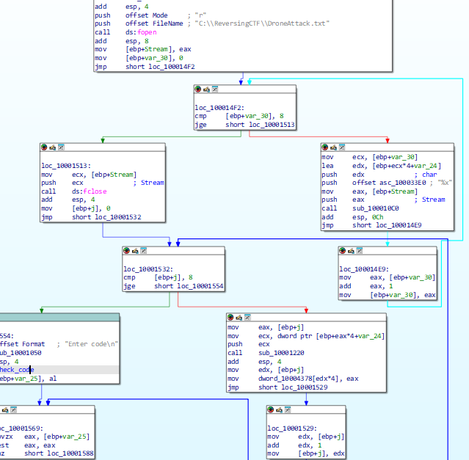

I had a hard time understanding what change was made to the file in static analysis.
Then I thought maybe I would completely change the values ​​in the file that would contain the same value 8 times so that the order wouldn't change so it was worth a try. I put the value 1 (of course you can put any value) in the file 8 times.
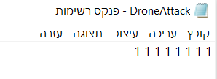

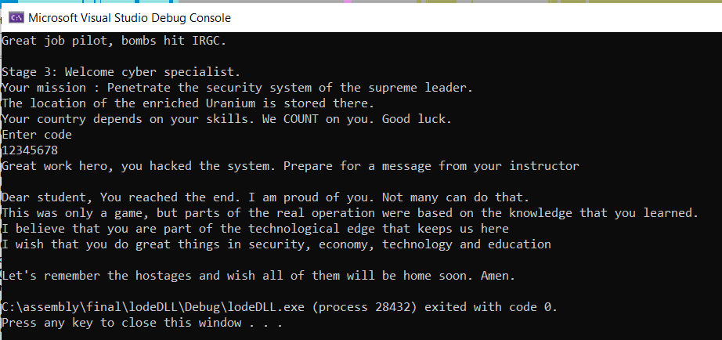
I entered the code 12345678 which meets all the conditions of the tests: an 8-digit code with values ​​1-8 without duplicates and now after the change in the file the last condition that checks that it was OK is meaningless because all the values ​​are equal.
And the code is correct, so you can put any code sequence that meets the following conditions, with 8 digits and values ​​between 1-8 without duplicates.
